## **Challenge One**

Solving the first challenge was simply a case of matching the symbols, replacing letters in the questions by using the provided key. This helped fill in the missing words. Then it was a case of working out which answer of the three choices was correct.

1. Where was the centre of **CODEBREAKING** in **WW2**?

Answer: Bletchley.

2. The man who designed the machine that **CRACKED** the **ENIGMA CODE** was...?

Answer: Turing.

3. The fundamental **BUILDING** block of **ELECTRONIC** devices is the...?

Answer: Transistor.

## **Challenge Two**

This question involved what is known as a substitution cipher - and a simple one at that.

Each letter was given a number starting with A=0, B=1, C=2 etc.

Applying that to the short sequence of numbers reveals the answer to be: **Fibonacci Sequence**.



Caesar is believed to have used a cipher that shifted letter positions to conceal messages

**Challenge Three**

The clue to getting this one right was in the picture.

It showed Julius Caesar, who was believed to have used codes that shifted each letter a few places to the right or left.

In the scheme we used, letters were moved three places to the right. The alphabet wraps round, so A=X, B=Y, C=Z and so on.

This gives the answer: **Up his sleevies.**

**Challenge Four**

To decipher: put a space after every 2 letters. Except for the last three letters. Leave them be: olts - ol ts. nia - nia. Then, switch the two (or three) letters around: ol ts - lo st. Nia - ain. Repeat for the next letters: lo st ti me is ne ve rf ou nd ag ain. Put them together, minus spaces: losttimeisneverfoundagain. Then, look at the title: 4, 4, 2, 5, 5, 5, 8, 8... they represent letters before a space: lost time is never found again. Use this rule (this time, all letters are the same) for the last part.   
  
It now should read:   
  
Lost time is never found again.   
-Benjamin Franklin.

**Challenge Five**

"Great Job You Got It"  
  
This type of code is known as a Caesar Box (Julius Caesar was the first to write codes this way.) To decipher the message, simply divide the code into four groups of four (you can also divide them into groups such as 5 groups of 5 or 6 groups of 6 depending on the number of letters in the phrase), and rearrange them vertically like this...  
G T Y O  
R J O T  
E O U I  
A B G T  
  
Then you read vertically column by column.

**Challenge Six**

The message was "loose bricks in left wall." The message was put backward with words related to time in between.  
  
This is how the message looks when separated:  
ll watch awtfe clock lnisk sundial cirbe timer sool  
  
If you take out watch, clock, sundial, and timer, this is what is left:  
llawtfelniskcirbesool  
  
Look at this backwards and this is what you have:  
loose bricks in left wall  
  
Auntie Bellum took out the bricks and escaped in the night. Then, she put the bricks back where they were.

## **Challenge Seven**

This code certainly stepped up the complexity, although there was a clue in the accompanying image.

Each number corresponds to the atomic number of an element.

Replacing the numbers with the initial letter of the element they represent should reveal the text below:

**The periodic table is a tabular arrangement of the chemical elements, organised on the basis of their atomic numbers, electron configurations, and recurring chemical properties. We've used it to create a cipher by using the initial letters of the elements, but two letters can't be used. What are they?**

The answer to the question posed in the revealed text is: **J and Q**.

<https://www.bbc.com/news/technology-35929741>

## **Challenge Eight**

The note said, "It was my wife!"  
  
The detective looked at the keypad on his phone and saw the letters next to the numbers.  
  
2,1 would be A  
2,2 would be B  
9,4 would be Z

## **Challenge Nine**

The final three challenges were genuinely difficult and required lateral thinking to work out how the text had been enciphered in the first place.

The numbers in puzzle one were for hexadecimal encoded Ascii characters. However, simply converting them back to the more familiar letters and punctuation marks would not give the answer.

Instead, it gave a string that had also been enciphered. It used a Caesar cipher that shifted the letters 13 places along the alphabet.

Reversing this change revealed the following text: **"We're all mad here. I'm mad. You're mad." "How do you know I'm mad?" said Alice. "You must be," said the Cat, "or you wouldn't have come here."**

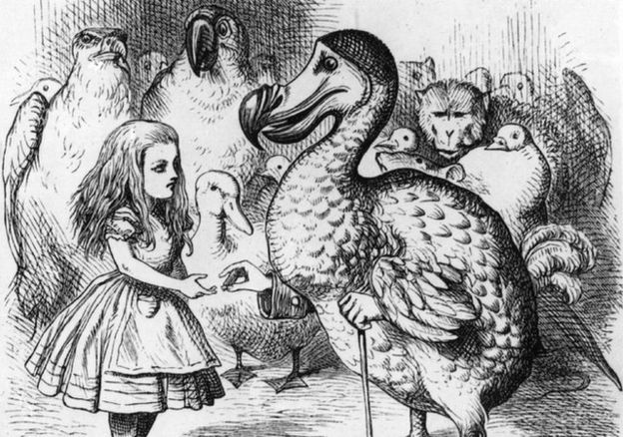

The theme linking the answers for the final challenge was Alice in Wonderland

Puzzle two was a bit of a beast. The key, literally, was using the five numbers arranged around the pentagon in the picture.

Starting at 3 and going clockwise gives the five character string 38108. Repeating this 29 times gives a string 145-characters long, the same length as the one below the pentagon.

Getting intelligible text out of this first requires using both strings and then performing what is known as an "exclusive or" (XOR) operation on them.

**[This website can help.](http://www.xor.pw/)**

Performing this operation produces another 145-character string that can be converted into English by looking up the numbers on a table of Ascii characters. Use the decimal column.

The sneaky part was realising that in some cases two numbers represented a character and in others it was three. Not easy.

Anyone who went through these steps would reveal the following text: **'It's a poor sort of memory that only works backwards.'**

By contrast to the preceding puzzle, number three was pretty straightforward once you worked out that the different types of pawns on the board represented the dots and dashes of Morse code.

Applying this revealed the message to be: **Off with their heads.**